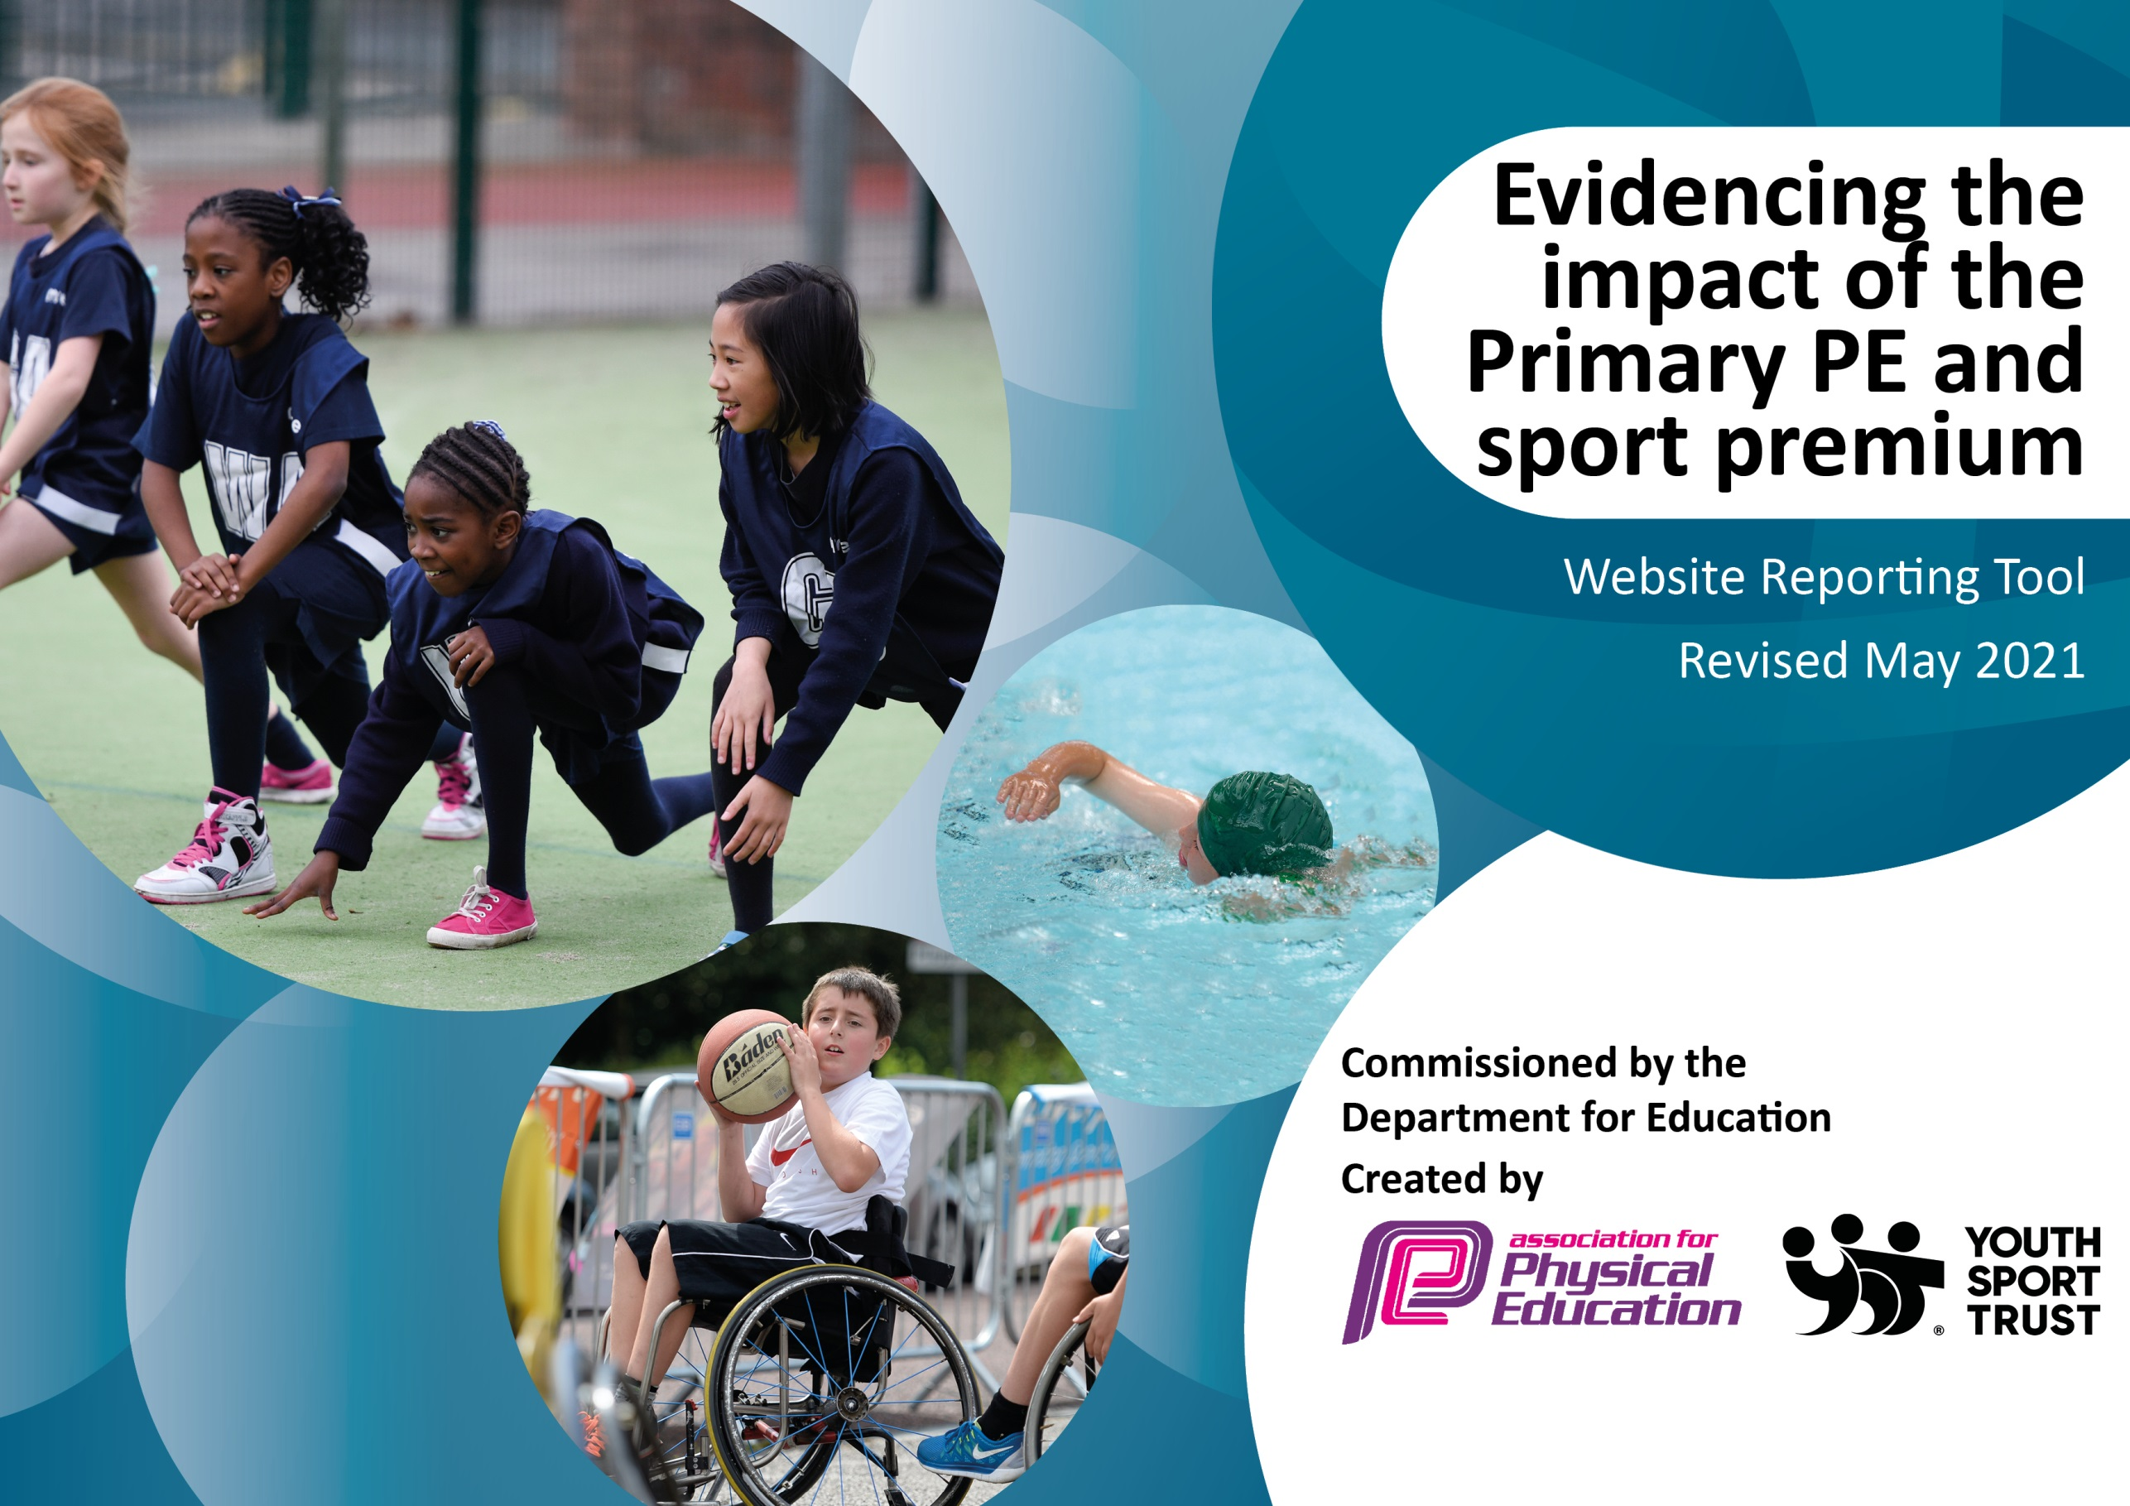

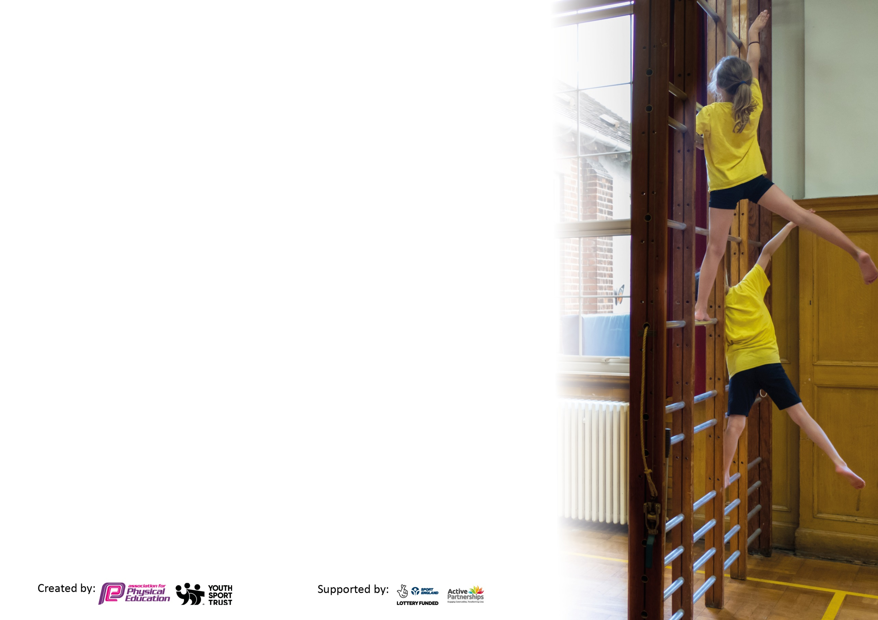

It is important that your grant is used effectively and based on school need. The Education Inspection Framework (Ofsted 2019 p64) makes clear there will be a focus on ‘whether leaders and those responsible for governors all understand their respective roles and perform these in a way that enhances the effectiveness of the school’.

Under the Quality of Education criteria (p41) inspectors consider the extent to which schools can articulate their curriculum (INTENT), construct their curriculum (IMPLEMENTATION) and demonstrate the outcomes which result (IMPACT).

To assist schools with common transferable language this template has been developed to utilise the same three headings which should make your plans easily transferable between working documents.

Schools must use the funding to make additional and sustainable improvements to the quality of Physical Education, School Sport and Physical Activity (PESSPA) they offer. This means that you should use the Primary PE and sport premium to:

- Develop or add to the PESSPA activities that your school already offer
- Build capacity and capability within the school to ensure that improvements made now will benefit pupils joining the school in future years
- The Primary PE and sport premium should not be used to fund capital spend projects; the school’s budget should fund these.

Please visit gov.uk for the revised DfE guidance including the 5 key indicators across which schools should demonstrate an improvement. This document will help you to review your provision and to report your spend. DfE encourages schools to use this template as an effective way of meeting the reporting requirements of the Primary PE and sport premium.

We recommend you start by reflecting on the impact of current provision and reviewing the previous spend.

Schools are required to publish details of how they spend this funding, including any under-spend from 2019/2020, as well as on the impact it has on pupils’ PE and sport participation and attainment by the end of the summer term or by 31st July 2021 at the latest.

We recommend regularly updating the table and publishing it on your website throughout the year. This evidences your ongoing self-evaluation of how you are using the funding to secure maximum, sustainable impact. Final copy must be posted on your website by the end of the academic year and no later than the 31st July 2021. To see an example of how to complete the table please click HERE.

Support for review and reflection - considering the 5 key indicators from DfE, what development needs are a priority for your setting and your pupils now and why? Use the space below to reflect on previous spend and key achievements and areas for development.

Please note: Although there has been considerable disruption in 2020 it is important that you publish details on your website of how you spend the funding - this is a legal requirement.

N.B. In this section you should refer to any adjustments you might have made due to Covid-19 and how these will influence further improvement.

Key achievements to date until July 2021: | Areas for further improvement and baseline evidence of need:
1.Continued specialist support with SC, BM and CMc throughout Covid.  2.Extended provision:  Small number of after school clubs started March 2021:  Mon-4/5 Yoga  Tues- 5/6 tag rugby  Wed -1 and 2 basketball  Thurs-3 and 4 football  Followed by morning clubs (June 2021)  Mon-1 and 2 multi skills  Thurs-5 and 6 football  Fri-3 and 4 basketball  3.Specialist dance teaching SB year 4 x 6 weeks –Merengue  4.Specialist dance teaching (Covid response funding with Kixx Education) FS2 x 6 weeks  5.Power of PE scheme of work purchased used by all staff.  6.Swimming resumed April 2021 12 weeks’ year 6-Swimstars and Dolphins  7.KS2 sports day-new venue Doncaster Athletics club  FS2, year 1 and 2 Sports activity day– 3 x specialist coaches –dance, football and fun games  FS1 mini sports day in hall for am and pm children  8.Taster sessions  4 week blocks with specialist coaches in cricket (year 2 and 4) and  Tennis (year 3) | The amounts are below:  2020-2021: Sports premium received: April –Aug £8,142 + Oct–March £11,393 = £19,535  Expenditure  Ipad: 174.85  Assessment app: 200.00  Equip inspection: 220.00  Stewart Cullen: 4,425.00  Basketball: 760.00  ActiveFusion: 250.00  Total spent: £6,029.85  19,535 – 6029.85 = £13,505.15 balance b/f  2021-2022: Sports premium received: April-Aug £8,137 received so far  Expenditure to date:  Transport (disputed from Covid): 330.00  Equipment: 1,404.32  ActiveFusion: 805.00  Stewart Cullen: 1,725.00  Fit4Rugby: 270.00  Basketball: 335.00  Kixx: 450.00  Total spend to 24.6.21: £5,319.32  PE Apprentice 1.9.21:  Approximate cost of salary: £5,000  Government grant: £3,000 –  £2,000  Total: £7,319.32  £8137-7319.32=£817.68  Balance b/f £817.68 + £11393 (second payment due)=£12,210.68  Proposed spending for monies b/f:  Equipment and resources for after school clubs-dance, tag rugby, football  Improved outdoor resources for FS unit-bikes etc  Employment of PE Apprentice-LJ  Focus area for academic year 2021/22-Dance  Specialist support-year 3 Academy of Northern Ballet project to start Sept 2021  Proposed 6 week blocks for dance in years 4,5 (to show progression from year 4) and 6 from Active Fusion.  Employ Active Fusion dance specialist for one half day per week for the full academic year to support lunchtime/curriculum and after school provision in dance and other areas. Silver partnership £3,120  Specialist Gym support- Kixx education (6 week block x 2 classes)  Full planned programme of before and after school clubs to start Sept 2021-led by specialist coaches.  Partial funding of morning /after school clubs by school for academic year 2021 -2022 TBC (5 x clubs per week, approx. £25 per hour=£125 x 39 weeks =£4875)  PE staff CPD –One staff meeting per term on PE in three different areas.  Area 1 –Gym Area 2- Dance and Area 3 –TBC  Extend swimming provision for academic year 2021 to 2022  Planned so far Jan to April 2022 swimming for:  Year 4 Monday am 12 weeks-approx £6000  Year 5 Tuesday pm 12 weeks-approx £6000  Year 6 Friday am 12 weeks-approx £6000

Did you carry forward an underspend from 2019-20 academic year into the current academic year? YES
Total amount carried forward from 2019/2020 £13,505.15 (Due to Covid March 2020 to July 2020)
+ Total amount for this academic year 2020/2021 £12,210.68
= Total to be spent by 31st July 2022 £25,715.83
Meeting national curriculum requirements for swimming and water safety.  N.B Complete this section to your best ability. For example, you might have practised safe self-rescue techniques on dry land which you can transfer to the pool when school swimming restarts.  Due to exceptional circumstances priority should be given to ensuring that pupils can perform safe self-rescue even  if they do not fully meet the first two requirements of the NC programme of study. | Swimming results below for year 6 July 2021
What percentage of your current Year 6 cohort swim competently, confidently and proficiently over a distance of at least 25 metres?  N.B. Even though your pupils may swim in another year please report on their attainment on leaving primary school at the end of the summer term 2021.  Please see note above. | 79%
What percentage of your current Year 6 cohort use a range of strokes effectively [for example, front crawl, backstroke and breaststroke]?  Please see note above. | 98%
What percentage of your current Year 6 cohort perform safe self-rescue in different water-based situations? | 97%
Schools can choose to use the Primary PE and sport premium to provide additional provision for swimming but this must be for activity over and above the national curriculum requirements. Have you used it in this way? | Plan to extend swimming provision to years 4,5 and 6 in academic year 2021/22.  Year 6 will be core provision (missed due to Covid in Y5), 4 and 5 extended provision.

Action Plan and Budget Tracking
Capture your intended annual spend against the 5 key indicators. Clarify the success criteria and evidence of impact that you intend to measure to evaluate for pupils today and for the future.

Academic Year: 2021/22 | Total fund allocated: £19,520  Paid in two instalments:  £11,387 October 2021  £8,133 April 2022 | Date Updated: September 2021
Key indicator 1: The engagement of all pupils in regular physical activity – Chief Medical Officers guidelines recommend that primary school pupils undertake at least 30 minutes of physical activity a day in school |  |  |  | Percentage of total allocation:
Intent | Implementation |  | Impact
Your school focus should be clear what you want the pupils to know and be able to do and about  what they need to learn and to  consolidate through practice: | Make sure your actions to achieve are linked to your intentions: | Funding allocated: | Evidence of impact: what do pupils now know and what can they now do? What has changed?: | Sustainability and suggested next steps:
To improve and structure playtime provision  To improve and enhance equipment for after school clubs | Ordering of new equipment:  Year ½ bag, year ¾ bag. year 5/6 bag- Each to include 1 x football, 1 x basketball and 10 skipping ropes  Sports coaches /PE apprentice to provide playtime activities:  JM/LJ-Mon  LJ-Tues/Wed/Fri  SC-Thurs  DR Foundation Jan 2022 playground leader training  New order placed for football, tag rugby and dance equipment | £176.74  £400  Total: £576.74
Key indicator 2: The profile of PESSPA being raised across the school as a tool for whole school improvement |  |  |  | Percentage of total allocation:
Intent | Implementation |  | Impact
Your school focus should be clear what you want the pupils to know and be able to do and about  what they need to learn and to  consolidate through practice: | Make sure your actions to achieve are linked to your intentions: | Funding allocated: | Evidence of impact: what do pupils now know and what can they now do? What has changed?: | Sustainability and suggested next steps:
To support the improvement of physical development in our EYFS children through a wide choice of quality equipment to develop large and small motor skills including agility.  To employ a PE apprentice to support and enhance our PE provision in school. | Having assessed what FS need and spoken with the FS team an order has been placed -trikes, balance poles, climbing wall, obstacle course, basketballs and hoop.  Building of block paving roadway with wet pour ramp for cycling skills  In EYFS  PE apprentice LJ to start Sept 2021  Mentor-SR  Supporting lessons and some before and after school clubs.  Assisting with lunchtime activities  Supporting adult for competitions | £2146.32  £3,945  £5000  Total: £11,091.31

Key indicator 3: Increased confidence, knowledge and skills of all staff in teaching PE and sport |  |  |  | Percentage of total allocation:
Intent | Implementation |  | Impact
Your school focus should be clear | Make sure your actions to | Funding | Evidence of impact: what do | Sustainability and suggested
what you want the pupils to know | achieve are linked to your | allocated: | pupils now know and what | next steps:
and be able to do and about | intentions: |  | can they now do? What has
what they need to learn and to |  |  | changed?:
consolidate through practice:
To use specialist staff to teach lessons and support teaching staff (staff CPD) | Monday pm –Active Fusion  Year 2 x 2 PE sessions  Lunchtime support/daily mile  Thursdays-SC all day.  Year 4 am x 2 classes  Lunchtime support/daily mile  Year 2 pm x 2 classes  Fridays-BM and CM basketball  Autumn 1 2 x FS2 lessons 45 minutes each  SR to teach PE:  Monday am-2 x year 1  Monday pm-2 x year 5  Tuesday all day-2 x year 6 am and 2 x year 5pm  Wednesday pm -2 x year 6 | £4380 for full academic year  £25 per hour  6 hrs per day=£150 per week x 40 weeks=£6000  £25 per hour  1.5hrs per day=£37.50 x 40=£1500  Percentage of SR wage £5000  Total:£16,880
Key indicator 4: Broader experience of a range of sports and activities offered to all pupils |  |  |  | Percentage of total allocation:
Intent | Implementation |  | Impact
Your school focus should be clear | Make sure your actions to | Funding | Evidence of impact: what do | Sustainability and suggested
what you want the pupils to know | achieve are linked to your | allocated: | pupils now know and what | next steps:
and be able to do and about | intentions: |  | can they now do? What has
what they need to learn and to |  |  | changed?:
consolidate through practice:
To provide children with an understanding of ballet with a basic knowledge of what makes it distinct from other dance styles  To improve dance provision and teaching throughout the school  To improve swimming skills in years 4 and 5. In particular, pupils should be taught to:  Swim competently, confidently and proficiently over a distance of at least 25 metres  Use a range of strokes effectively [for example, front crawl, backstroke and breaststroke]  Perform safe self-rescue in different water-based situations.  To provide a broad range of before and after school clubs to suit all ages and abilities. | September 2021-Chance to Dance project for Year 3 children.  Our year 3 children are taking part in the Chance to Dance project this term. This is a creative ballet programme run by the Royal Opera House’s Learning and Participation department. This will be led by LS our Year 3 teacher and supported by the Royal Opera House Artists during one of their PE lessons in the Autumn term.  JM Active Fusion Mon pm to support children and staff in the teaching of the dance curriculum.  Year 6 will have swimming this year as their core entitlement.  We are extending this to provide further swimming lessons for year 4 and 5. All these children will have an hourly swimming lesson starting January 2021 for 12 weeks provided by Swimstars and Dolphins.  To extend sports club provision:  Provision for September 2021 before and after school.  Monday am Fun games (Sam Walton) Y1 and 2  Monday pm James Merrick (Active Fusion) Dance  KS2  Tuesday am Fun games (Sam Walton)  Tuesday pm KS2 Gymnastics  Cara Moscardini (Kixx Education)  KS2  Wednesday am Football (Sam Walton) Y5 and 6  Wed pm BM/CM Basketball year 3 and 4  Thursday am Stewart Cullan football Y1 and 2  Thursday pm SC Tag Rugby  Y5 and 6  Friday am Bob Martin/Cat Mc Cafferty Basketball Y1/2  Friday pm Taekwondo  Luke Millar Active Fusion KS2 | £300  See above  £6000 x 2=£12000  Parents to pay £2 per session.  School to subsidise session £500  Total: £12,800

Key indicator 5: Increased participation in competitive sport |  |  |  | Percentage of total allocation:
 |  |  |  | %
Intent | Implementation |  | Impact
Your school focus should be clear | Make sure your actions to | Funding | Evidence of impact: what do | Sustainability and suggested
what you want the pupils to know | achieve are linked to your | allocated: | pupils now know and what | next steps:
and be able to do and about | intentions: |  | can they now do? What has
what they need to learn and to |  |  | changed?:
consolidate through practice:
To provide opportunities for children to take part in competitive sport. | Engage in the School Games programme and Active Fusion’s calendar of sporting events.  Compete in SC competitive sport calendar.  Compete in Active Fusion –Fusion Five Series. A virtual multi skills competition.  Compete in Pyramid sporting events- Hall Cross.  (When these all recommence) | To include:  Average taxi:  £30 return  Average Coach hire: £300  Staffing to sports events:  £500  Total £2500 approx  Total overall spend:  £43,848.05  Total to be spent by 31st July 2022  (from Covid years)  £25,715.83  plus  Total fund allocated for academic year 2021/22 £19,520=  £45,235.83  £45,235.83-  £43,848.05=  £1387.78  remaining

Signed off by
Head Teacher: | 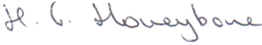
Date: | 17.11.21
Subject Leader: | Mrs S Raven
Date: | 10.11.21
Governor: | V.Harper-Ward
Date: | 17.11.21

