Town Field
Primary
School

Reading Guide

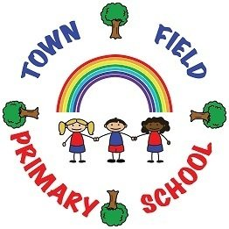

Subject leader: Jennifer D’Rozario

The aims of reading at Town Field Primary School

We aim for all our children to:

- Become enthusiastic, fluent and confident readers, regardless of their background, needs or abilities
- have access to a range of stories, poems, rhymes and non-fiction texts which will develop their vocabulary, language comprehension and a love of reading
- receive rapid and targeted intervention if they need support to meet age-related expectations

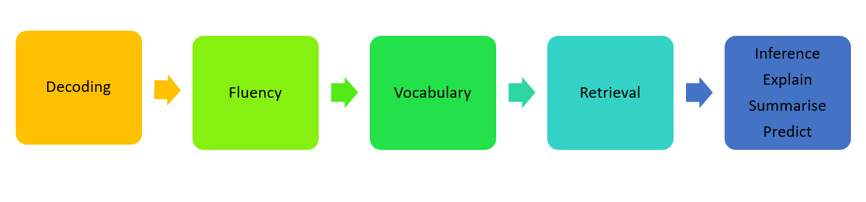
Sequence of teaching
At Town Field Primary we have a rigorous and sequential approach to the reading curriculum. A minimum of two hours per week is dedicated to the teaching of reading in each year group. This time is segmented across the weekly timetable to allow for shorter, more frequent sessions. As a result, reading skills are cumulatively built up over the course of the week to enable a deeper understanding of texts.

Teaching and Learning Strategies

The Town Field Reading Process has been developed to incorporate all the essential elements that underpin the teaching of reading. The Reading Process places age-appropriate, quality texts at the heart of the reading curriculum with children being exposed to a range of stories, poems, rhymes and non-fiction texts.

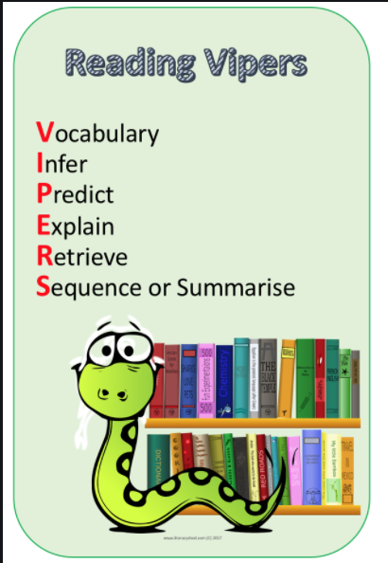
In order to develop children’s comprehension skills, Reading VIPERS are used during reading lessons. The VIPERS correspond directly with the reading content domains for each year group: they are used to develop children's understanding of the texts they read through targeted questioning linked to each domain.

Teacher-led class discussion forms a large part of comprehension sessions. Children receive feedback to their responses at the point of learning. This allows teachers to shape pupils’ responses effectively to strengthen their understanding of texts through addressing misconceptions and to extend the learning of children who require additional challenge.

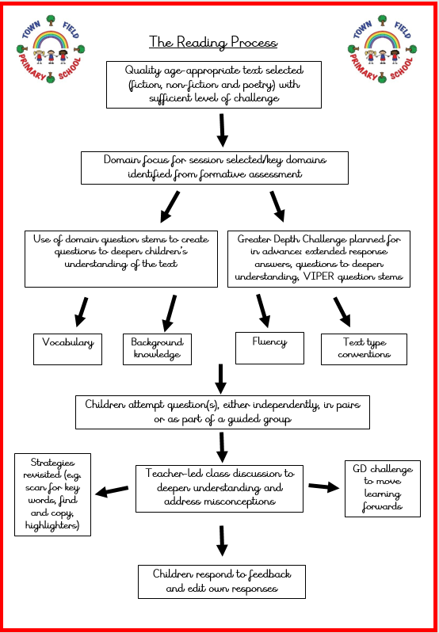

Assessment and Intervention

Formative assessment is used within reading sessions to identify children in need of additional support to achieve age-related expectations. In Key Stage Two, Headstart Assessment is used termly to support with summative teacher assessment.

The Town Field Reading Diagnostic Pack is used as a tool to provide teachers with an in-depth understanding a child’s capabilities and difficulties and to match pupils to appropriate interventions. High-quality, structured reading interventions enable gaps to be quickly and effectively addressed. Intervention trackers map children’s progress and provide summative judgements which support with identification for structured intervention groups.

Town Field Intervention Menu:

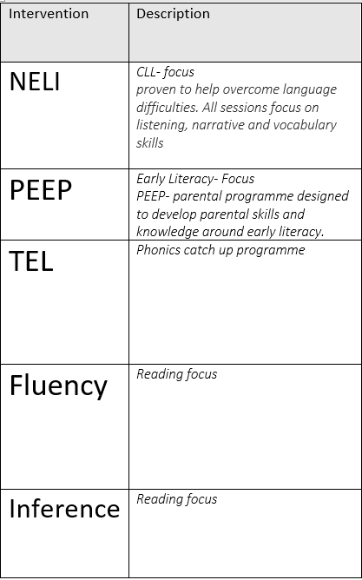

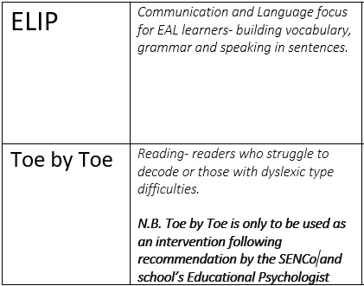

Reading for Pleasure

Town Field is a reading community with parents, pupils and staff all sharing a love of reading. We have developed a parent working group to create a reading culture that extends beyond the school gates. Our children have many opportunities to engage with reading beyond reading lessons and to nurture, develop and stretch their talents and interests. These include World Book Day, Book Fair, Reading Credit Rewards and links with Doncaster Children’s Library Service and the National Literacy Trust.

To celebrate positive attitudes to reading, there is a nominated ‘Reader of the Week’ per class. Children can also accumulate reading credits for modelling good reading habits such as practising their reading at home, engaging in discussions about books and recommending books to peers. These can then be exchanged at our Town Field Book Shop for a free book to keep.

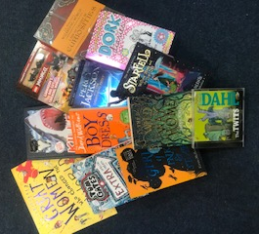
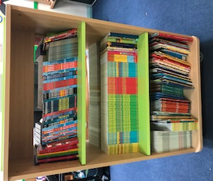

How and where children’s work should be recorded
- Children’s written work should be recorded in their Reading Journal book
- Children are to use green pen to alter their answers in response to feedback
- Reading Journals are to be monitored by the class teacher for basic skills, quality of presentation and spellings. Corrections to be made in green pen.

