Pupil premium strategy statement 2020-2023

This statement details our school’s use of pupil premium (and recovery premium for the 2022 to 2023 academic year) funding to help improve the attainment of our disadvantaged pupils.

It outlines our pupil premium strategy, how we intend to spend the funding in this academic year and the effect that last year’s spending of pupil premium had within our school.

School overview
Detail | Data
School name | Town Field Primary School
Number of pupils in school | 469
Proportion (%) of pupil premium eligible pupils | 23.03%
Academic year/years that our current pupil premium strategy plan covers | 2021-2023
Date this statement was published | November 2021 (previously on old format Sept 21)
Date on which it will be reviewed | September 2022 ( Interim review April 2022)
Statement authorised by | Helena Honeybone
Pupil premium lead | Matthew Brandham
Governor / Trustee lead | Sian Derry
Funding overview
Detail | Amount
Pupil premium funding allocation this academic year | £149,580
Recovery premium funding allocation this academic year | £13,485
Pupil premium funding carried forward from previous years (enter £0 if not applicable) | £0
Total budget for this academic year  If your school is an academy in a trust that pools this funding, state the amount available to your school this academic year | £163,065

Part A: Pupil premium strategy plan

Statement of intent
We aim for our curriculum provision to support all children, irrespective of their background, to be successful at Town Field. We need to have a clear understanding of challenges that individual children face and our strategy is to support the needs of children at Town Field.
Beginning with quality first teaching, pupil premium funding enables us to be at the forefront of pedagogical approaches, ensuring teachers support all pupils to achieve their potential. Where gaps exist due to Covid the pupil premium funding supports a range of high quality diagnostic assessments. A range of research based interventions are then delivered and measured by trained staff.
We aim to equip every child with the vocabulary and skills to be fluent readers; our intervention programme supports this goal.
Our inclusive, caring ethos at Town Field means that every child is supported pastorally. Pupil premium funding allows us to put in additional support for a child’s mental health and well-being where a need has been identified.
A focus on character education for all is an important aspect of our intent at Town Field. Pupil premium funding supports the development of cultural capital for many of our children who face challenges to learning through socio-economic disadvantage.

Challenges

This details the key challenges to achievement that we have identified among our disadvantaged pupils.
Challenge number | Detail of challenge
1 | A high percentage of pupils start school without the necessary skills in language and communication. This has also been impacted significantly by Covid where opportunities to socialise and build cultural capital have been minimised.
2 | Assessments, observations and pupil feedback have identified gaps in phonic knowledge which impacts significantly on children’s ability to develop into fluent readers. This is further inhibited by lockdown for some pupils.
3 | In some cases, pupil attendance at school has been impacted particularly over recent lockdowns. Attendance figures 20/21 stand at whole school 96.4% v PP attendance of 94.07%.  Attendance for 21/22 stands at:  Whole school attendance 92.1% v PP attendance of 90.9%  However, PP attendance is above national of 90.5%  *Our attendance was particularly affected by a Chicken Pox outbreak in Y1 and the Heatwave in late July 2022.
4 | Enrichment activities have been limited due to Covid – this has impacted on pupil’s character education and cultural capital.
5 | Assessments and observations indicate that children’s attainment in writing has been impacted on significantly from school closures. This includes the mechanics of writing and comprehension skills.
6 | Assessments and observations indicate that children’s attainment in reading has been impacted on significantly from school closures. Vocabulary acquisition is a barrier to many pupils across school.
7 | Parental support and understanding impacts on learners. The recent lockdown has impacted significantly on families in our community in particular our most disadvantaged.

Intended outcomes
This explains the outcomes we are aiming for by the end of our current strategy plan, and how we will measure whether they have been achieved.
Intended outcome | Success criteria
Improved language and oral skills | Assessments and observations indicate significant improvements in oral language amongst pupils. This is evident when triangulated with other sources of evidence including , engagement in lessons, formative assessment and book scrutiny
Improved outcomes in phonics | To achieve above national average in phonics (aiming for 95+%).  Staff CPD ensures consistent and quality delivery across phonics classes
Improved attendance for all pupils in particular those that are disadvantaged | A sustained high attendance by our percentage staying in line with national figures. At or above 96%  The attendance gap between pupil premium children and their peers being reduced
To improve the cultural capital and curriculum enrichment opportunities for our children | Pupil voice speaks highly of opportunities they receive  An increase in participation in enrichment activities in school particularly by those who are disadvantaged  A promotion of opportunities outside of school increases pupil well being
To improve attainment for all pupils in writing | To achieve above national average progress scores in writing
To improve attainment for all pupils in reading | To achieve above national average progress scores in reading
To support and sustain positive levels of parental engagement in particular with our most disadvantaged families | Evidence of families being supported by school PSA and support with other agencies  Pupil voice demonstrates improving well being

academic year
This details how we intend to spend our pupil premium (and recovery premium funding) this academic year to address the challenges listed above.

Teaching (for example, CPD, recruitment and retention)
Budgeted cost: £ 55,000
Activity | Evidence that supports this approach | Challenge number(s) addressed
Teacher to pupil ratio increased in key areas to enable quality researched interventions and accelerate pupil progress | Sutton Trust found that “ The effects of high quality teaching are especially significant for pupils from disadvantaged backgrounds. 1.5+ years’ progress as a result of highly effective teaching  https://www.suttontrust.com/our-research/?_sf_s=teaching | 1,2,5,6
Purchase of standardised diagnostic assessments.  Training of staff to ensure assessments are interpreted and administered correctly as well as allowing us to compare with similar schools in the trust | Standardised tests can provide reliable insights into the specific strengths and weaknesses of each pupil to help ensure they receive the correct additional support through interventions or teacher instruction | 1,2,5,6
New writing programme to be purchased and implemented across school – Pathways to Write  CPD whole school and trial in year 2 and 5. This is a mastery approach to writing | 2020 winner of The education resource awards.  https://educationendowmentfoundation.org.uk/education-evidence/guidance-reports/literacy-ks2 | 1,5
Maths intervention implemented across school to support pupils who are not meeting expected standard.  This is now an identified focus. It will supplement our Maths Mastery approach.  Number blocks will also be used to support KS1. | https://www.ncetm.org.uk/teaching-for-mastery/mastery-explained/supporting-research-evidence-and-argument/  https://www.arkcurriculumplus.org.uk/our-programmes/primary/mathematics-mastery | 1
To continue to build on the solid foundations laid in 21/22. Little Wandle Revised Letters and Sounds programme – Staff trained and scheme integrated and taught effectively across EYFS and KS1  This will also include a  rapid catch up and SEND intervention | DFE Approved SSP programme to ensure continuity, clarity and progression through phonics teaching  DFE - By ensuring high-quality phonics teach-ing the government wants to improve liter-acy levels to:  • give all children a solid base upon which to build as they progress through school  . help children to develop the habit of reading widely and often, for both pleasure and information particularly for disadvantaged pupils  https://www.littlewandlelettersandsounds.org.uk/resources/my-letters-and-sounds/ | 1,2
Let’s think in English – staff trained and programme developed effectively across school  This was delayed in 21/22 for a number of reasons – rolled out as a trial in across Year groups in summer 2. It will begin in earnest in Autumn 1 22/23 | Let’s Think in English is designed on exactly the same principles as Cognitive Acceleration in Science Education (CASE) which was developed and repeatedly trialled over 30 years at King’s College London.  https://www.letsthinkinenglish.org/lets-think-in-english-for-primary-schools/ | 1,2,6

Targeted academic support (for example, tutoring, one-to-one support structured interventions)
Budgeted cost: £ 65,000
Activity | Evidence that supports this approach | Challenge number(s) addressed
Additional Phonic/fluency interventions to support pupils in LKS2 (where necessary to recover from lost learning during pandemic) | EEF: Phonics has a positive impact overall (+5 months) with very extensive evidence and is an important component in the development of early reading skills, particularly for children from disadvantaged backgrounds. | 6
Additional phonics interventions to support those pupils included those that are disadvantaged (KS1) | Phonics approaches have strong evidence base indicating a positive impact on pupils, particularly those that are disadvantaged backgrounds. Targeted phonics interventions have been shown to be more effective when delivered as regular sessions over a period of up to 12 weeks.  Phonics|Toolkit Strand| education Endowment Foundation|EEF | 2
Fluency intervention for identified pupils | Fluent reading supports comprehension because pupils’ cognitive resources can be redirected from focusing on word recognition to comprehending the text.  https://educationendowmentfoundation.org.uk/education-evidence/guidance-reports/literacy-ks2 | 2,6
Inference intervention for identified pupils | It is important for reading comprehension strategy  interventions to focus on enabling pupils to use the  strategies independently and habitually, with less and less prompting from the teacher.  https://educationendowmentfoundation.org.uk/education-evidence/guidance-reports/literacy-ks2 | 2,6
NELI intervention within EYFS for identified pupils | The trial found that children receiving the NELI programme made the equivalent of +3 additional months’ progress in oral language skills compared to children who did not receive NELI. It received 5 out of 5 on the EEF padlock scale which means we can be very confident in the results of the evaluation. Children receiving the NELI programme also made more progress in early word reading (+2 months) and children with English as an additional language benefited just as much from the programme as native English speakers.  https://www.teachneli.org/what-is-neli/evidence-and-programme-development/ | 1
EAL Hub | High quality strategies to support those pupils new to English and those building their proficiency to enable full access to the curriculum. | 1
Individual and/or group tutor sessions which will be used to ensure that support is well-targeted and to monitor pupil progress. This will be formative based initially. Small group and/or one to one tuition with particular focus on (dependent on year group) phonics, reading, writing arithmetic/basic maths skills. These will be taught by experienced qualified teachers and an experienced TA | Gaps identified in formative assessment allow for precisely targeted teaching to remedy these-  Small group tuition having an impact of +4 months (EEF)  Meta-Analysis of research by John Hattie breaks down quality teaching into:  Pupils having clear goals/objectives.  Teachers providing pupils with modelling/scaffolding/appropriate steps to achieve them. | 1,2,5,6

Wider strategies (for example, related to attendance, behaviour, wellbeing)
Budgeted cost: £40,000
Activity | Evidence that supports this approach | Challenge number(s) addressed
To work closely with new EWO and develop strategies aligned to the new attendance directives to support this area. Regular meetings, letters and rewards for good attendance. As well as providing enriched curriculum opportunities for those with improved attendance. | Approaches to developing a positive school ethos or improving discipline across the whole school which also aim to support greater engagement in learning. Both targeted interventions and universal approaches have positive overall effects (+ 4 months) | 1,3,7
To ensure the promotion of parental engagement at Town Field so that the community works together to ensure social and academic progress for all within it. This to include supporting mental health. | A low percentage of pupils start school with the necessary skills in language and communication. Also Covid has had a huge impact on families and pupils in our community. Limiting the chance to have experiences and enjoy the normalities of life and increasing anxieties and low self-confidence. EEF evidence shows building up relationships between families and school can impact positively on outcomes by children learning and sharing experiences away from school. | 1,3,7
Parent support officer employed to support families | Parental engagement has a positive impact on average of 4 months’ additional progress. It is crucial to consider how to engage with all parents to avoid widening attainment gaps.  https://educationendowmentfoundation.org.uk/education-evidence/teaching-learning-toolkit/parental-engagement | 1,3,7
Enriched curriculum opportunities including sports, art and culture as well as before and after school activities to help develop an inspiration social emotional skills and cultural understanding.  CAS – Create active schools programme | There is a small positive impact of physical activity on academic attainment (+1 month). While this evidence summary focuses on the link between physical activity and academic performance, it is crucial to ensure that pupils access to high quality physical activity for the other benefits and opportunities it provides.  Arts participation approaches can have a positive impact on academic outcomes in other areas of the curriculum.+ 3 months | 1,4
Music  Opportunities for Year 3/4/5 to access wider opportunities.  Group music tuition across KS2  Aiming at a whole school summer production.  We are also aspiring Culture champions – working alongside the Royal Opera House | Enhancing our music provision impacts positively on our pupils https://educationendowmentfoundation.org.uk/projects-and-evaluation/projects/first-thing-music | 1,4
Rugby League World Cup – purchasing tickets for KS2 pupils to attend a live game – inspiring children to be involved in live sport and a momentous occasion for the city. | Taking advantage of world class sport in our city. As above EEF denotes a positive impact of sports, art and music on our pupils – ranging from 1 month to 4 months  https://educationendowmentfoundation.org.uk/education-evidence/teaching-learning-toolkit/physical-activity | 1,4
Engaging with Doncaster Chamber to enhance our curriculum offer, focussing on future careers and aspirations | Building cultural capital to support those most disadvantaged. Children and young people have missed over six months of in-person education during the pandemic – almost 5% of their entire educational career. Disadvantaged students have been the most affected and will require significant and targeted support. | 4

Total budgeted cost: £163,065

Part B: Review of outcomes in the previous academic year

Pupil premium strategy outcomes
This details the impact that our pupil premium activity had on pupils in the 2020 to 2021 academic year.
Improved language and oral skills | Staff in EYFS have worked particularly hard to develop opportunities for developing language in the setting.  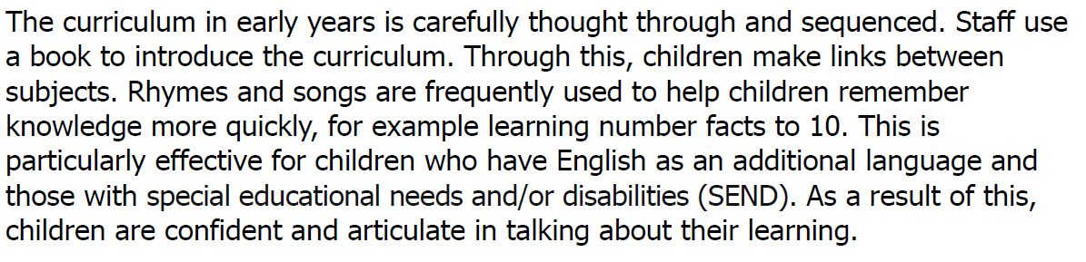  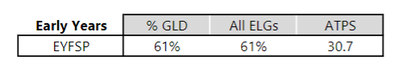
Improved outcomes in phonics | The strong implementation of the Little Wandle programme has had significant impact on our pupils and staff. Subject knowledge has improved and delivery across Early Years and KS1 is consistent. There is also support in place for pupils in KS2 who need it – through phonic intervention.  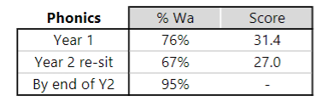
Improved attendance for all pupils in particular those that are disadvantaged | The development of a school vulnerable check list has supported in us creating a positive attitude to attendance.  Figures for the school are positive – including some of our most vulnerable.  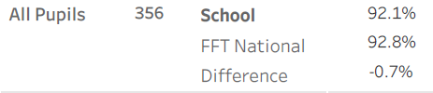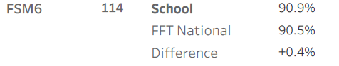  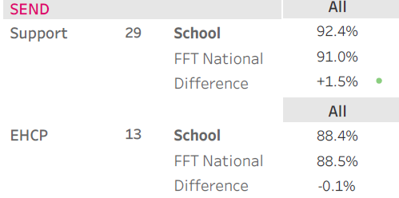
To improve the cultural capital and curriculum enrichment opportunities for our children | Work done with Doncaster to chamber to provide culture capital and curriculum enrichment opportunities for our children.  Trips subsidised for our children enabling all to attend – for example Y6 trip to Hatfield Water Park.  Reptile Rendez-Vous, Amazon, Polypipe trips to the seaside all supported our pupil’s development. Culture capital activities map available of request. With the ease of Covid trips and residentials already booked in for 22/23.  Ofsted recognised the hard work done by staff to provide a rich curriculum for our pupils.  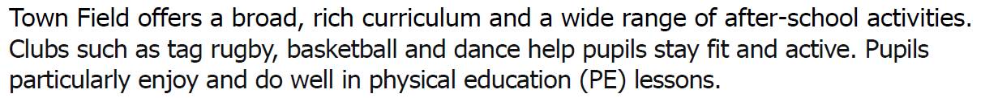
To improve attainment for all pupils in writing | This is on going and with the purchase of a new strategy Pathways to Write we are hoping to see strong foundations built across school.  KS1  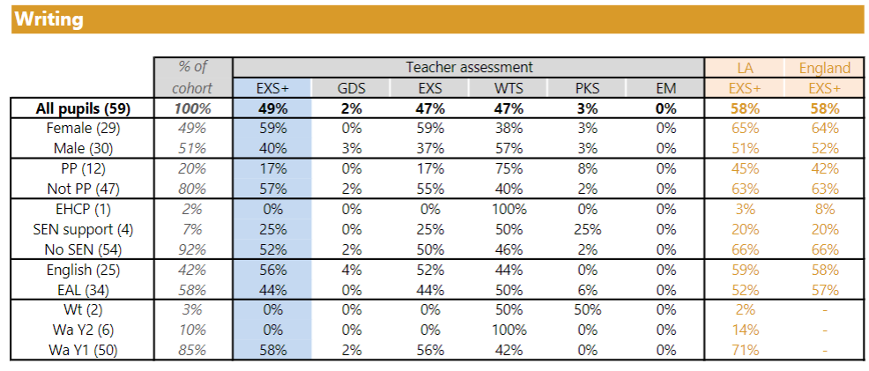  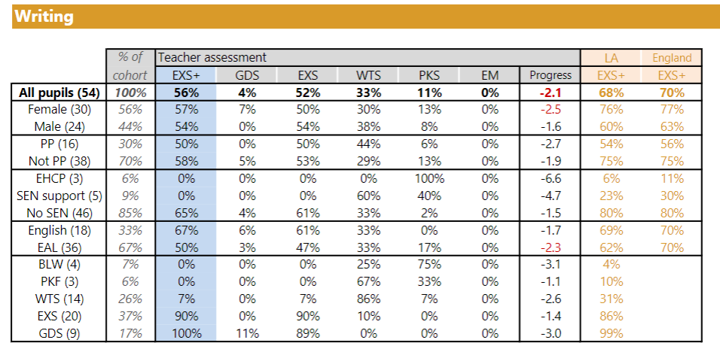
To improve attainment for all pupils in reading | KS1  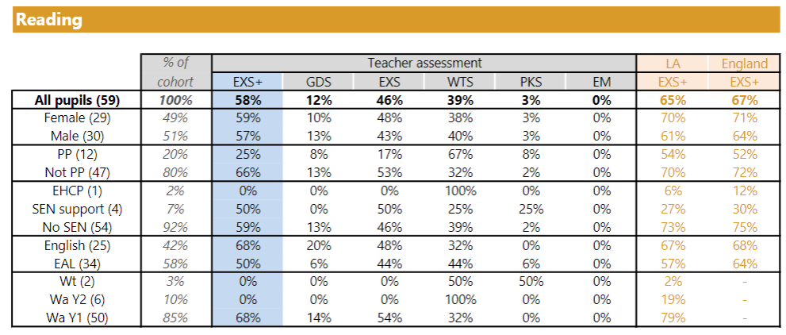  KS2  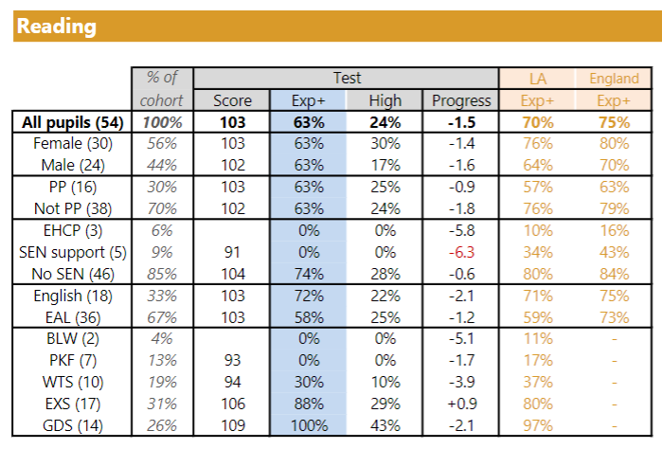
To support and sustain positive levels of parental engagement in particular with our most disadvantaged families | The school has worked hard to engage with parents and relationships continue to build and be strong.  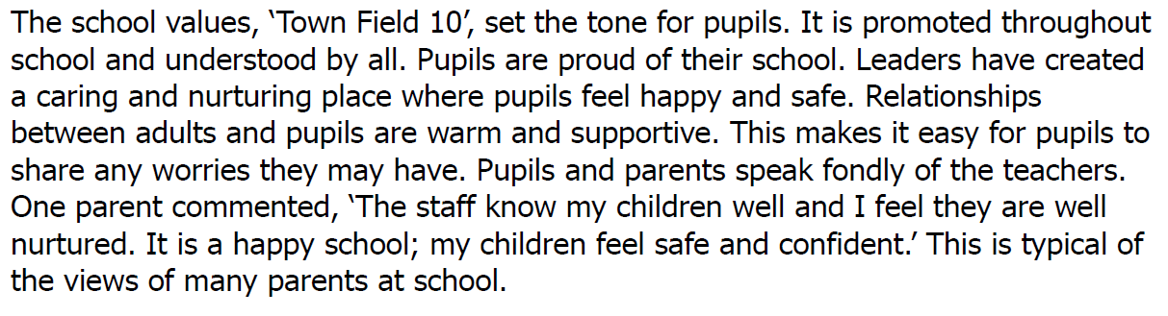  The school PSA works hard with a number of families to ensure that they are supported during this challenging time. Conversations, calls and emails are exchanged regularly and well-being checks conducted.  3 x CP  3 x LAC  13 x TAC  50+ children who are deemed vulnerable  Work shops supporting mental health are planned for 22/23 academic year.

Externally provided programmes
Please include the names of any non-DfE programmes that you purchased in the previous academic year. This will help the Department for Education identify which ones are popular in England
Programme | Provider
LTIE | Kings College London
Power of PE | Power of PE

Service pupil premium funding (optional)
For schools that receive this funding, you may wish to provide the following information:
Measure | Details
How did you spend your service pupil premium allocation last academic year? | N/A
What was the impact of that spending on service pupil premium eligible pupils? | N/A

Further information (optional)
Positive relationships with range of professional partners including Partners in Learning and The Doncaster Research School, Learners First and Rotherham Literacy hub to continue to study the impact of disadvantage on education outcomes and how to address challenges to learning presented by socio-economic disadvantage to assess how effectively we use our pupil premium and recovery funding. The school has also sought to strengthen links with music and behaviour services.

